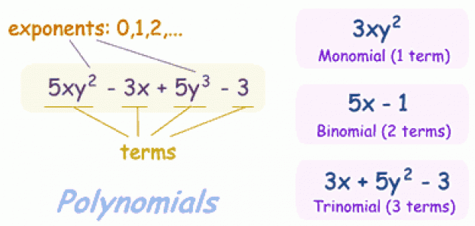

Degree of a monomial - Sum of the exponents of the variables

Ex 1 2x^@ +

14x^4y^2-35x^2y^6+x^3\*y^2= 8